Create Database Student;

Create Table Personal_info(Std_id int(2) primary key,Name varchar(6),age int(2));

Insert into Personal_info values(1,'Montu',35);

Insert into Personal_info values(2,'Ambia',31);

Insert into Personal_info values(2,'Ambia_returns',32);

Insert into personal_info values(3,'Tuni',33);

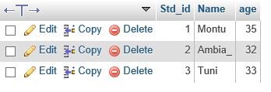

Create Table Academic_info(Std_id int(2) unique,Dept varchar(5),Series int(2));

Insert into Academic_info values(1,'CSE',75);

Insert into Academic_info values(2,'ETE',78);

Insert into Academic_info values(2,'EEE'

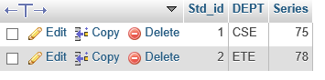.

Alter Table aCADEMIC_INFO ADD column CLASS_ROLL int(2);

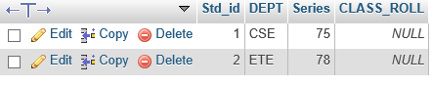

Update academic_info set class_roll =1 where series=75;

Update academic_info set class_roll =1 where series=78;

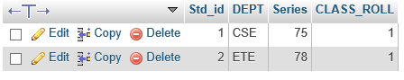

Update academic_info set class_roll =1 where series=77;

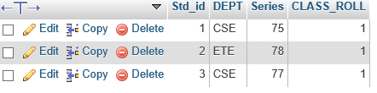

Alter Table Academic_info primary key(Std_id);

Select *from personal_info where Name like'%i%';

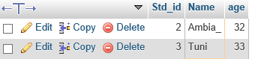

Select *from Academic_info where DEPT like 'CS%';

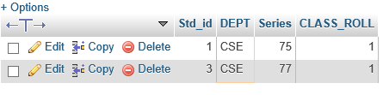

Select *from personal_info where Name like'__n%';

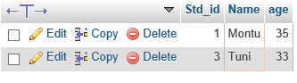

Select *from personal_info where Age>30 AND age<35;

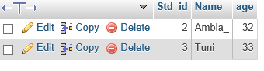

Select *from Academic_info where series IN(71,73,75,77,79);

